Jonas and Roman encoding speed comparison

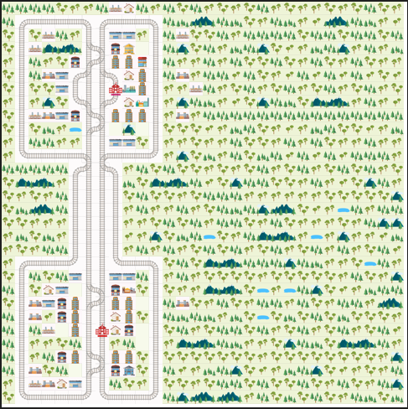
These results are on this environment running two trains.

Roman:
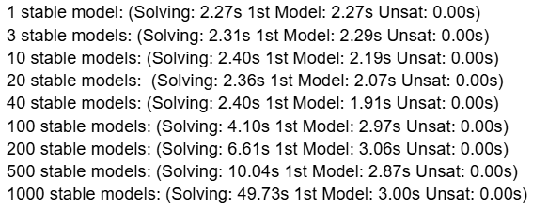

Jonas (without minimize statement and run without --quiet=2 parameter):
1 stable model: 0.074s (Solving: 0.02s 1st Model: 0.00s Unsat: 0.00s)
3 stable models: 0.115s (Solving: 0.03s 1st Model: 0.00s Unsat: 0.00s)
10 stable models: 0.178s (Solving: 0.13s 1st Model: 0.00s Unsat: 0.00s)
20 stable models: 0.180s (Solving: 0.12s 1st Model: 0.00s Unsat: 0.00s)
40 stable models: 0.276s (Solving: 0.22s 1st Model: 0.00s Unsat: 0.00s)
100 stable models: 0.366s (Solving: 0.31s 1st Model: 0.00s Unsat: 0.01s)
200 stable models: 0.544s (Solving: 0.49s 1st Model: 0.00s Unsat: 0.01s)
500 stable models: 0.365s (Solving: 0.31s 1st Model: 0.00s Unsat: 0.01s)
1000 stable models: 0.409s (Solving: 0.36s 1st Model: 0.00s Unsat: 0.01s)

Jonas (without minimize statement and with quiet parameter):
1 model: 0.062s (Solving: 0.00s 1st Model: 0.00s Unsat: 0.00s)
3 models: 0.057s (Solving: 0.00s 1st Model: 0.00s Unsat: 0.00s)
10 models: 0.113s (Solving: 0.00s 1st Model: 0.00s Unsat: 0.00s)
20 models: 0.050s (Solving: 0.00s 1st Model: 0.00s Unsat: 0.00s)
40 models: 0.048s (Solving: 0.00s 1st Model: 0.00s Unsat: 0.00s)
100 models: 0.065s (Solving: 0.00s 1st Model: 0.00s Unsat: 0.00s)
200 models: 0.050s (Solving: 0.00s 1st Model: 0.00s Unsat: 0.00s)
500 models: 0.050s (Solving: 0.00s 1st Model: 0.00s Unsat: 0.00s)
1000 models: 0.049s (Solving: 0.00s 1st Model: 0.00s Unsat: 0.00s)

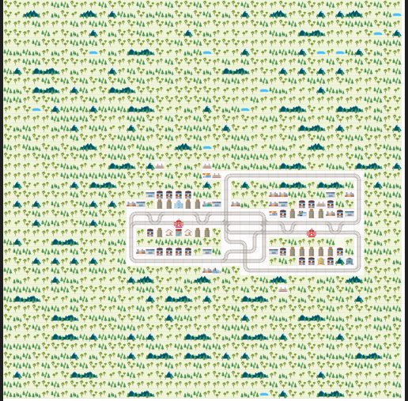
These results are on this environment running two trains.
Roman:
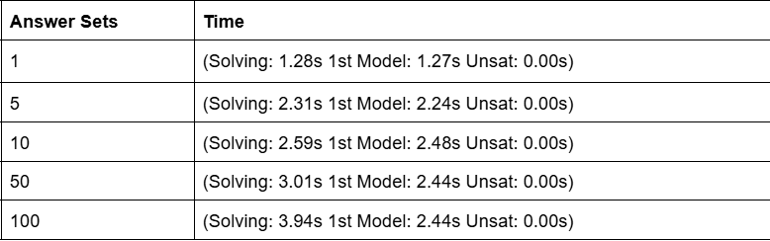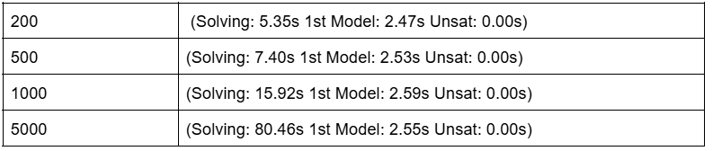

Jonas (without minimize statement and without quiet parameter):
1 model: 0.140s (Solving: 0.01s 1st Model: 0.00s Unsat: 0.00s)
3 models: 0.155s (Solving: 0.02s 1st Model: 0.00s Unsat: 0.00s)
10 models: 0.196s (Solving: 0.06s 1st Model: 0.00s Unsat: 0.00s)
20 models: 0.253s (Solving: 0.11s 1st Model: 0.00s Unsat: 0.00s)
40 models: 0.367s (Solving: 0.24s 1st Model: 0.00s Unsat: 0.00s)
100 models: 0.765s (Solving: 0.63s 1st Model: 0.00s Unsat: 0.00s)
200 models: 1.231s (Solving: 1.11s 1st Model: 0.00s Unsat: 0.00s)
500 models: 4.757s (Solving: 4.61s 1st Model: 0.01s Unsat: 0.00s)
1000 models: 6.741s (Solving: 6.60s 1st Model: 0.01s Unsat: 0.00s)
5000 models: 36.741s (Solving: 36.58s 1st Model: 0.00s Unsat: 0.00s)

